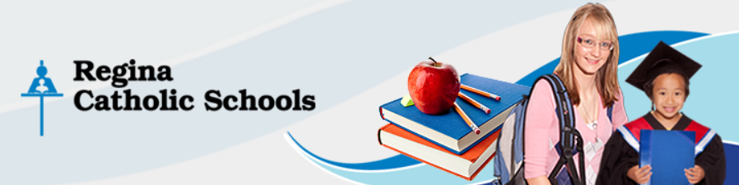

Podcasting Media Consent Form

I understand that all student podcasts may be used for educational purposes. All posted podcasts may be posted to a teacher’s YouTube account, blog, or other podcast hosting service. I understand that any video that I have created may be posted to different formats for public viewing. I also am aware that no copyrighted material of any kind can be present in the podcasts, including copyrighted music, audio, photography or video.

Please indicate your wishes regarding your child’s involvement in posting completed projects by completed the form below and returning to your child’s homeroom teacher.
YES, I permit my child to post completed podcast projects online. These resources can be posted to public websites such a Vimeo, Youtube, School Websites and blogs.

NO, I do not permit my child to post completed podcast projects online. These resources can be posted to public websites such a Vimeo, Youtube, School Websites and blogs.

School Name:

Students Name:

Homeroom Teacher:

Parent/Guardian Signature:

Date:

